FOR IMMEDIATE RELEASE

Please contact Allison Therrien at associate.director@rebeccahossack.com or 212-925-3500 with any press inquiries.

Alasdair Wallace: Rare Vagrants & Accidentals

April 16 – May 7, 2014

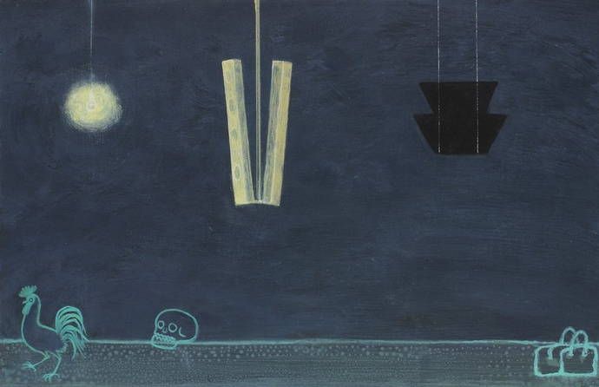

New York, NY – Rebecca Hossack Gallery is proud to present Alasdair Wallace: Rare Vagrants & Accidentals, a solo exhibition featuring painted works by Glasgow-based artist Alasdair Wallace. The exhibition will commence with an opening reception on Wednesday, April 16 from 6-8PM, and will close on May 7th.

Born in Glasgow in 1967, Alasdair Wallace grew up on the border between city and countryside. The world of his childhood was one of tower blocks silhouetted against distant hills, where the glare of a street lamp might suddenly illuminate a fox, where abandoned domestic appliances hung in the branches of thorn bushes, and wind-blown Tesco bags flew around with the circling birds.

The recurring elements of his artistic landscape have gained an almost symbolic force. Wallace himself calls them “absurd icons” – a lone figure on a tree stump with a dartboard on his back, a limp parakeet hanging from a tree branch. Birds are mute witnesses to the unfolding scene, and the human figures are touched by the oddness of it all. Wallace’s work provides a window into an unexplained world, at once recognizable and bizarre.

The individuality of Wallace’s vision is matched by his technique. Colors are built up through layers of paint and seem to glow. Oblique references to Ovid’s Metamorphosis populate the work and contextualize it amidst a mythological universality. The paintings in Rare Vagrants & Accidentals range from being intimate in scale – depicting individual figures, trees, rocks, and buildings – and expansive, yet riddled with brilliant detail.

About Rebecca Hossack Gallery

The Rebecca Hossack Gallery in New York was opened in May 2011, and was
founded by the renowned London art dealer Rebecca Hossack to sit globally alongside her two successful London galleries. Originally from Australia, Hossack founded the London galleries in 1988 and has built a reputation for exhibiting contemporary art of rare individual vision.

The New York City gallery space resides at 262 Mott Street in Nolita.

