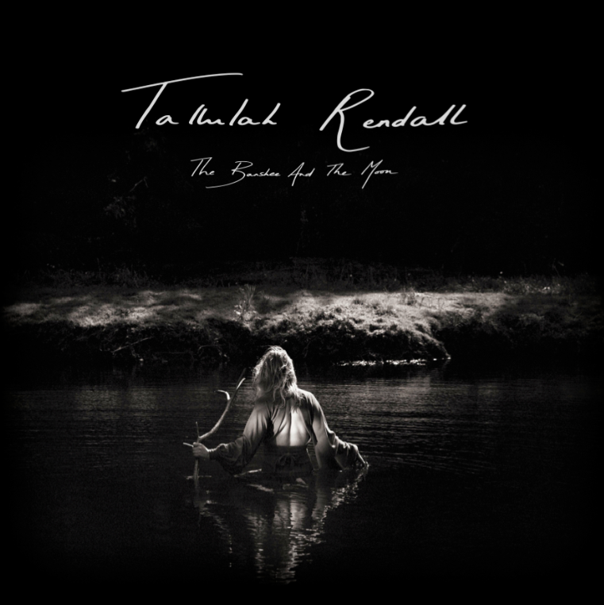
Tallulah Rendall
Third Album
The Banshee and the Moon
Written & Performed by Tallulah
Format: Book, CD and Vinyl

LAUNCH EVENT
Album Exhibition & Performance:
‘The Banshee and the Moon’
Exhibition & Performance Date:
Wed 28th May— Thurs 31st May 2014
6-9pm Daily
RSVP For Seated Performances 7-8pm
Location: Rebecca Hossack Art Gallery
2a Conway Street, Fitzroy Square,
London W1T 6BA

“The phrase ‘female singer-songwriter’ conjures up images of pastels, acoustic guitars and whistling. That isn’t Tallulah Rendall’s style. When I saw her perform at Bermondsey’s Shunt she was a Bowie-esque giant in gold spangles, intimidating and glorious, and her music had an intense sense of psychosis behind its lilting melodies.” Michael Rundle

“In this world of homogenised pop and rock, it’s these moments of something a bit different, something with a dollop of good old fashioned British eccentricity, that makes music interesting.” Spoonfed

'LONDON’S MOST CREATIVE WOMAN' (AOL/Asylum)
From 28th – 31st May Tallulah Rendall will showcase her newest crowd-funded record, The Banshee and the Moon. Following her past two albums, Libellus and Alive, with songs such as Canary said to defy “categorisation, incorporating elements from electronic, grunge and indie music style, but morphing them into a truly authentic and original entity” (Nick Shaikh) and presented within a hardback book narrating the story behind its creation. The songs themselves are each represented by a landscape black and white photograph taken by one of the four photographers, Serena Bolton, Akio, Paris Acrkill, Ben Heron and Jamie Croft, that Tallulah collaborated with over the past two years.

Recorded on Osea Island with producer Danton Supple (Coldplay, Morrissey) who noted:
“working with Tallulah was a privilege and a pleasure. The breadth of her vocals along with the passion of her delivery was always inspiring and to have had her play so many of the instruments brought a real focus to the songs. She's a natural performer, whether in front of one person or an arena, and really deserves success in this industry."

Tallulah is the sole driving force behind both her music and career and is often considered a maverick after her decision in 2005 to not only crowd fund her records, but present them as books (digital versions as well as hardbacks) and releasing them on her label Transducer Records. Each book includes the album, tells the story behind her independent journey for each record as well as the story behind the songs and her decision to represent each track through a piece of art, photography or film. There is also a collector’s limited edition 12" vinyl of the album available with a download code.

Musically, this record is reminiscent of the rich tapestry of artist’s such as Apparat with a canvas of lush harmonies underpinned by rolling base lines and the wildness of Patti Smith. Song-wise, the album moves wave like from the more epic tracks of Land Away, The Banshee, Pieces, Run Let The River Run to the intimacy of Eyes, Lost In The Moonlight, Shine On and Trust In Me, and narrates the past two years of Tallulah’s life moving from London to Berlin’s creative chaos, then to Bristol and finally the wild solitude of Devon; all the while inspired by her muse, the Banshee. These transitions also coincided with her decision to write all the instrumentation for this album and record it on her own, with producer Danton Supple. Determined to harness her experience of world tours and performing live, Tallulah wanted to capture, both her live energy and unique songwriter style on this record.

To celebrate the completion of this project, Rebecca Hossack Art Gallery will be hosting a four-day exhibition from 28th May – 31st May 2014. This will be a presentation of the album’s photographs, plus nightly seated performances, followed by a UK tour. After the success of Tallulah’s three-month UK and German living room tour in 2013, Tallulah has decided once again to embark on a tour hosted by fans around the country. This will be interspersed by festival and venue gigs.

To attend one of the nightly launch events please RSVP to tallulahrendall@gmail.com

For more information, promos requests or to set up an interview, please contact:
Email: tallulahrendallmusic@gmail.com
WWW.TALLULAHRENDALL.COM
